

Project report



Fangyuan Cao

201652575

fcao

Steps to run my application:

1. Start an Apache Service

2. Start a MySQL Server

3. Open the webpage through the link localhost/fcao.html

4. Enter the information that is indicated on the web page to retrieve needed records

Screenshots

Query 1

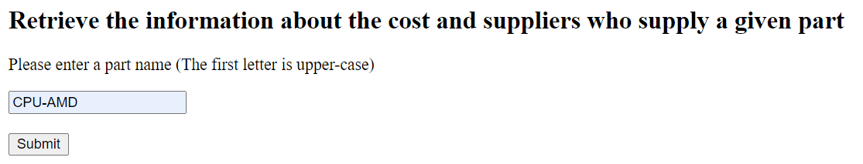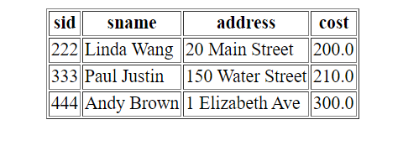

Query 2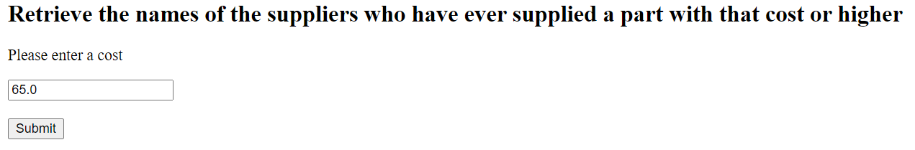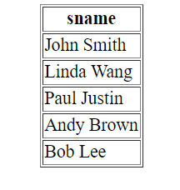

Query 3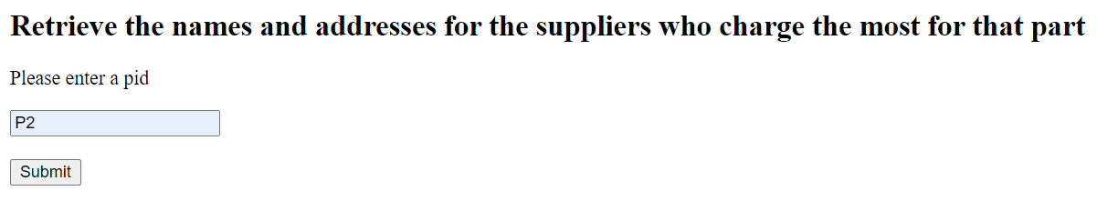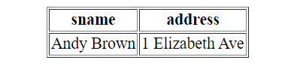

Query 4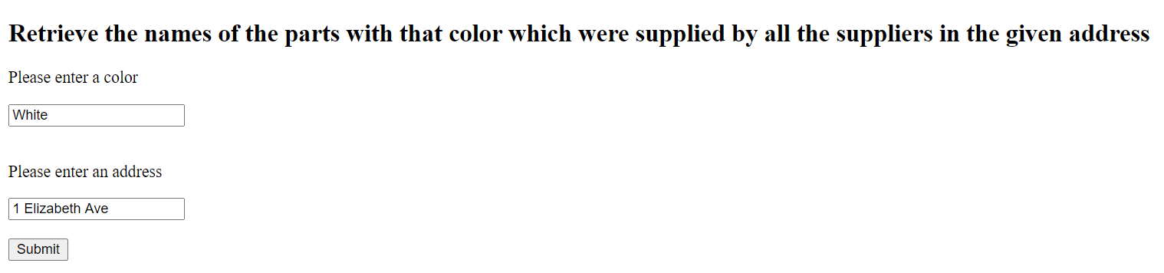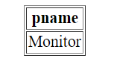

Query 5